

VERTICAL DIFFUSION PM PROCEDURE (Poly)
PM Type: SPM – Small PM Prepared by:
Machine: LP-Poly Robin 羅彬森
PM Frequency: 9μ±1小PM S200 FURNACE
Date: July 2019

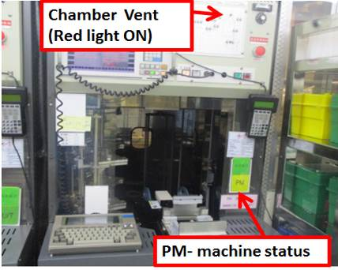 |  | 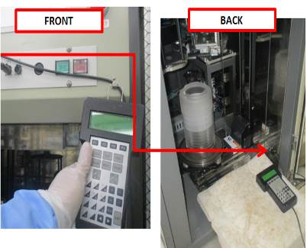 |  | 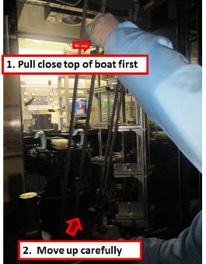
1. Confirm if machine ready for PM, check if machine already vent |  | 2. Get controller from front of machine, and connect to back terminal on lower right side. |  | 3. Remove old boat

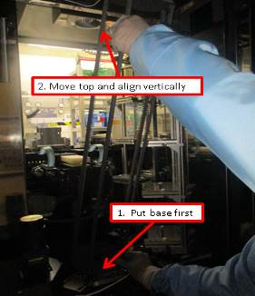 |  | 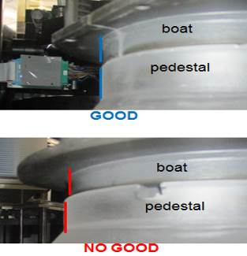 |  | 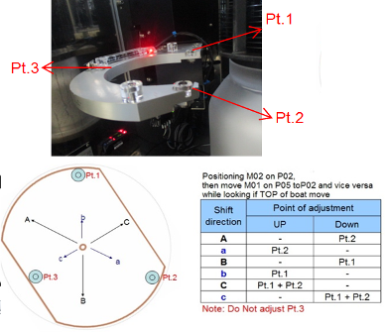
4. Install new boat |  | 5. Put M06 in P01, put boat on top of pedestal and check alignment |  | 6. while M02 is in P02, Move M01 between P02 and P05, adjust if top of boat move

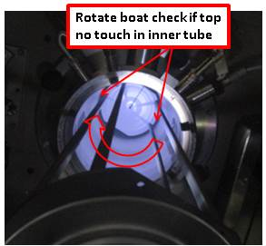 |  | 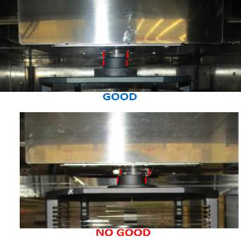 |  | 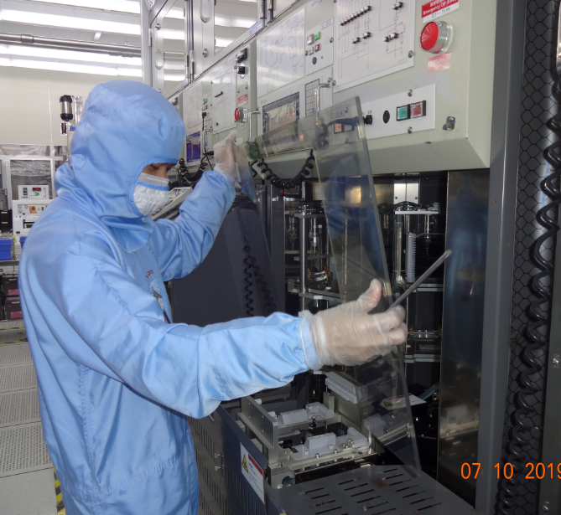
7. Check chamber and boat gap, move boat at Ht.=1000 and rotate360deg |  | 8. Put M02 in P01 to check/adjust boat lock |  | 9. remove machine front cover and load 7 cassette dummy wafer

Doc. #: 2019-CRP-001 rev.03 Page 1 of 2

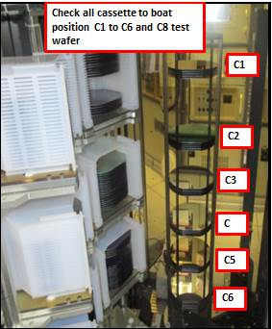 |  | 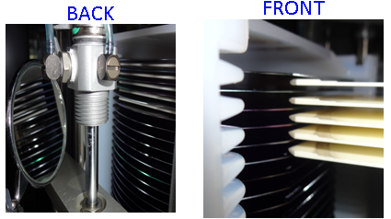 |  | 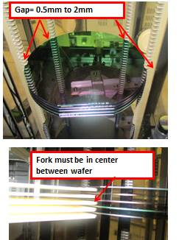
10. transfer wafer from cassette to boat and check gap |  | 11. check fork gap between wafer if center(front and back) use mirror tool |  | 12. Check/adjust wafer position on boat, and fork gap between wafers

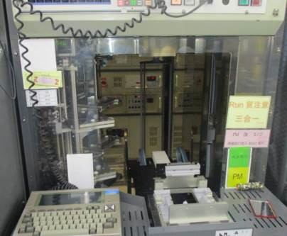 |  | 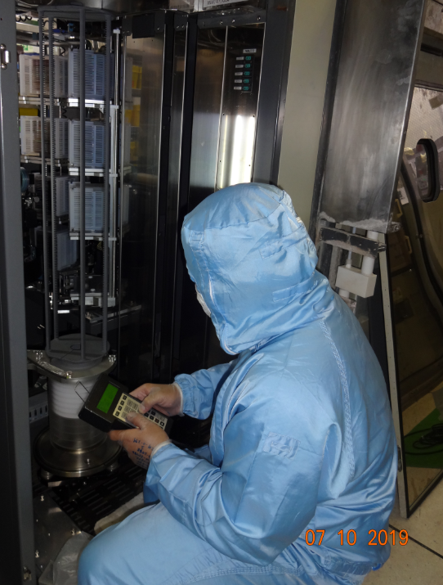 |  | 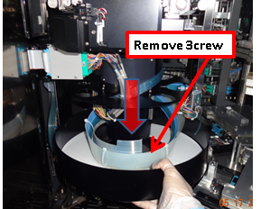
13. Unload dummy wafer and cassette, and install front cover |  | 14. Take VL800 controller at back side machine and move UP boat inside chamber. Double check position |  | 15. Remove robot assembly pan and clean air hose

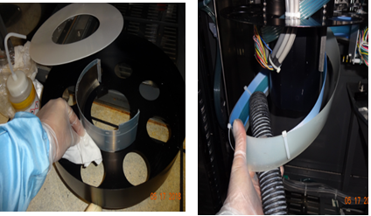 |  | 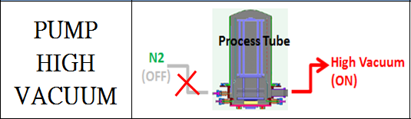 |  | 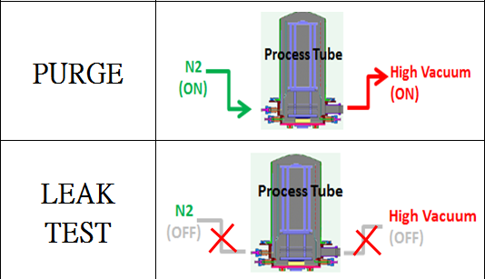
16. Clean robot assembly pan and Teflon mat, use IPA and low vacuum and install |  | 17. Close chamber and Pump High vacuum. Until base pressure 0.00Torr |  | 18. Open heater and purge 1 Hr, then leak test at High temperature. Pressure  0.02Torr/130sec

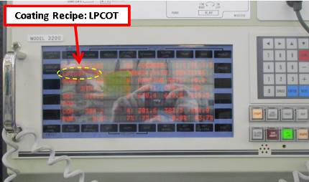 |  | EA TEST RUN
19. input coating recipe for poly machine |  | 20. fill up machine log book PM OK and endorse to EA for test run
Doc. #: 2019-CRP-001 rev.03 Page 2 of 2

